Assignment 2:
Badshah Jan (2280175)
BSSE-7B
LAB 8:
TASK 1:
Virtual Machine:
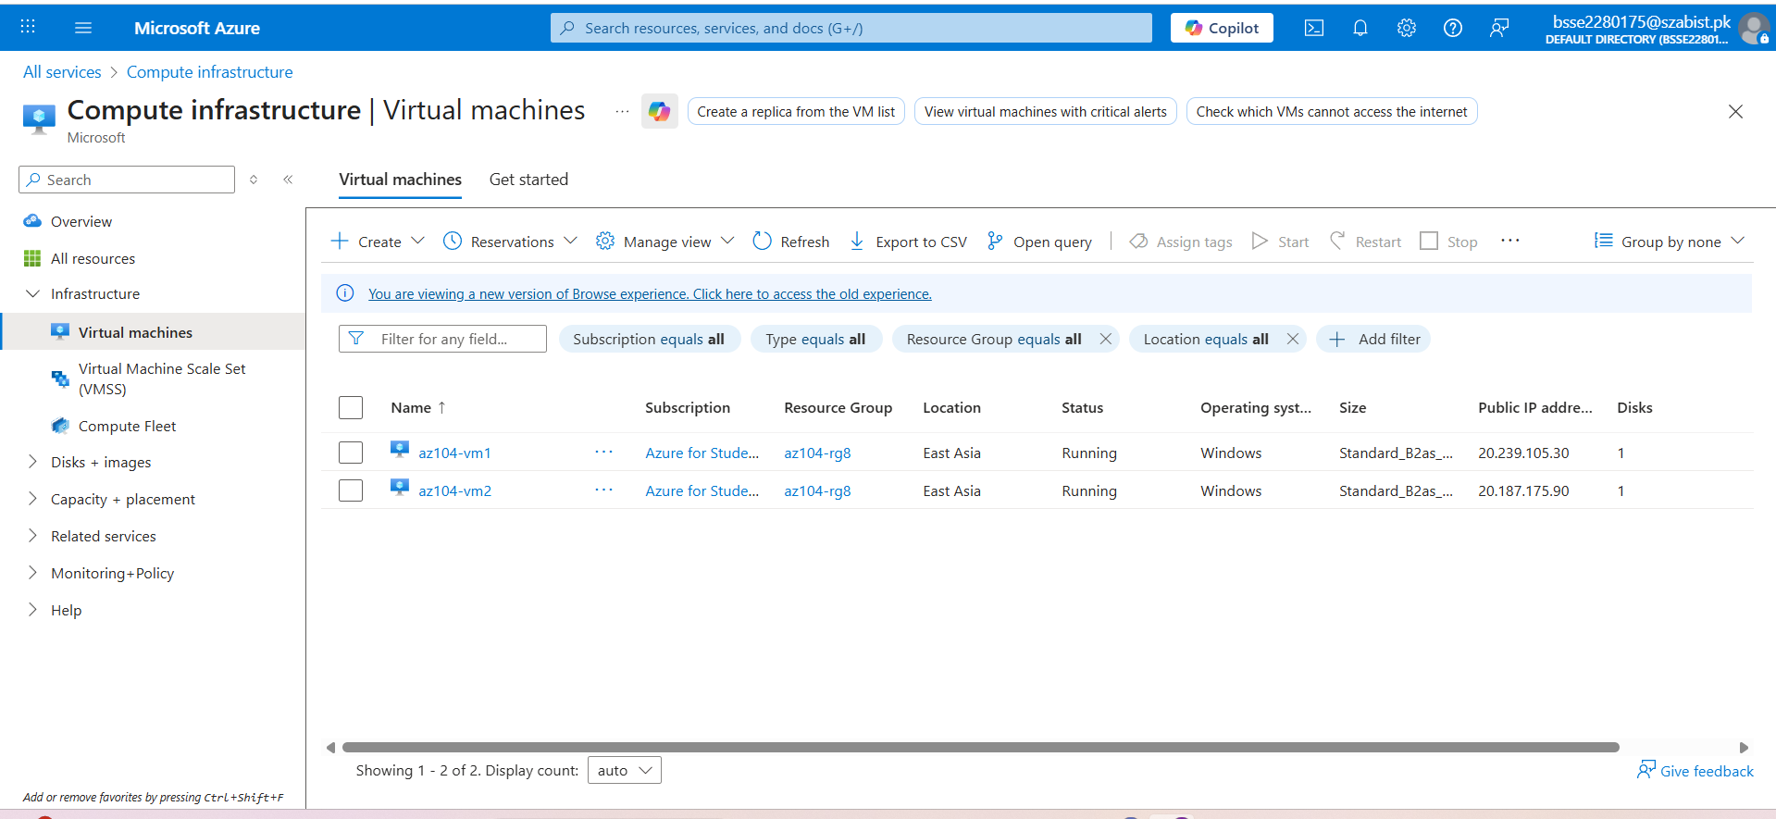

VM 1:
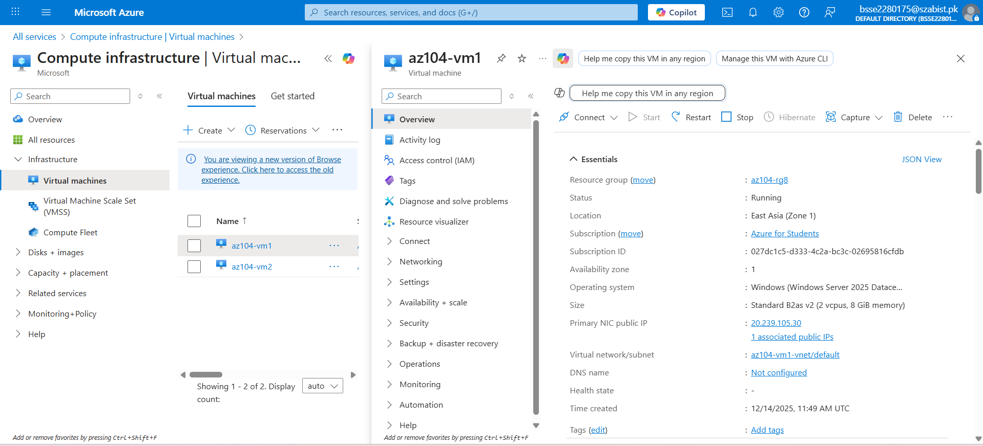

VM 2:
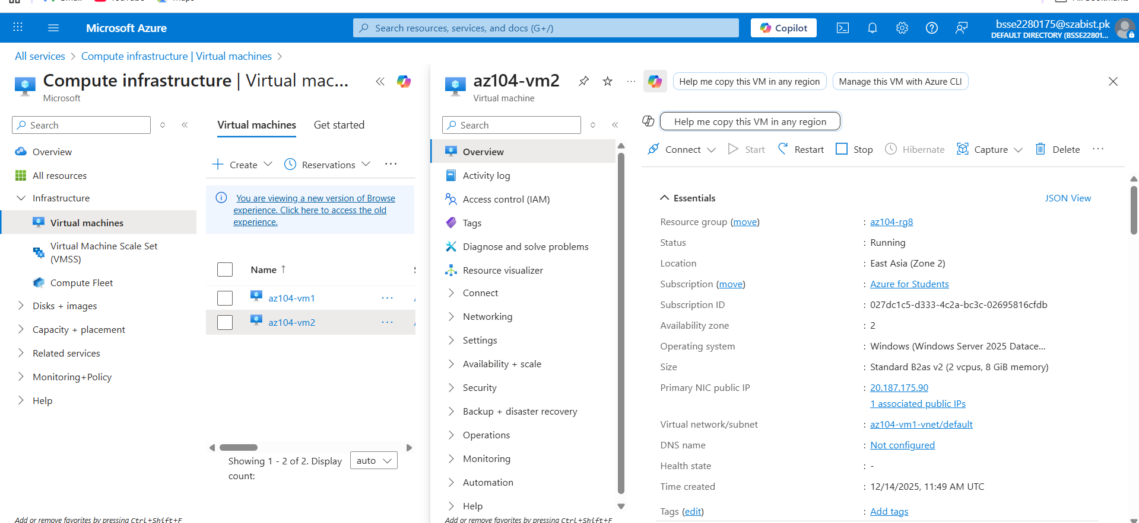

TASK 2:
RESIZE VM:
The VM was resized to a higher Standard SKU to meet performance requirements and demonstrate compute scaling:
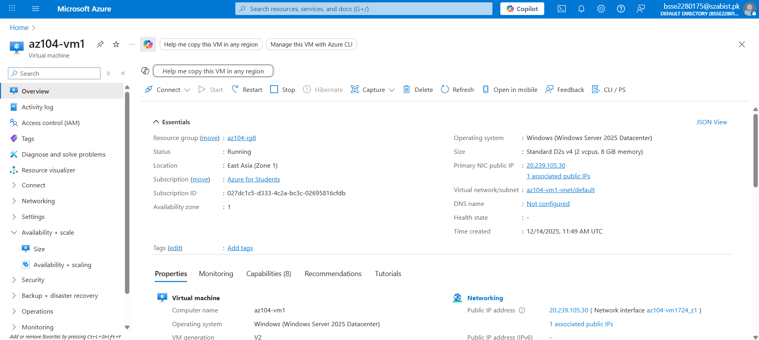

VM Disks:
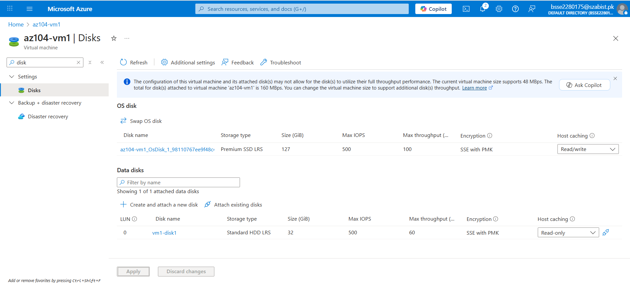
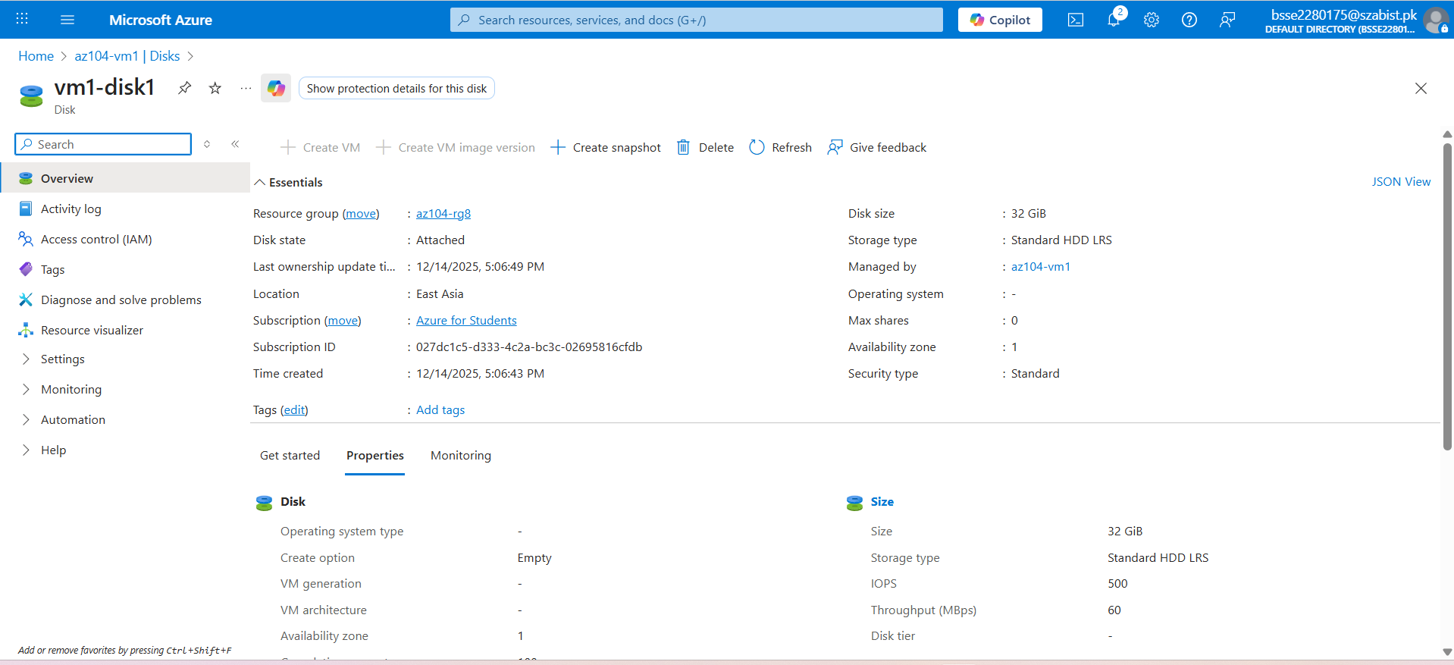
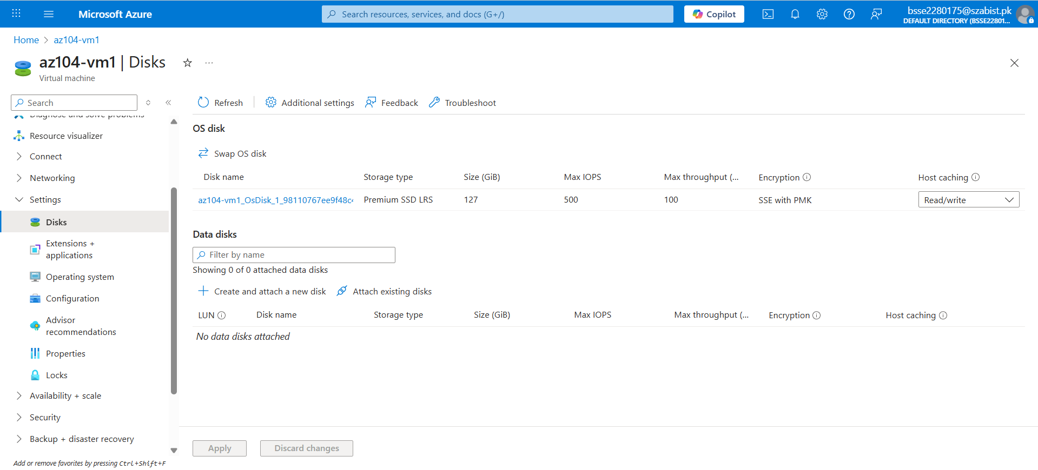

TASK 2 – STEP 4: DATA DISK TYPE CHANGE (HDD → SSD):
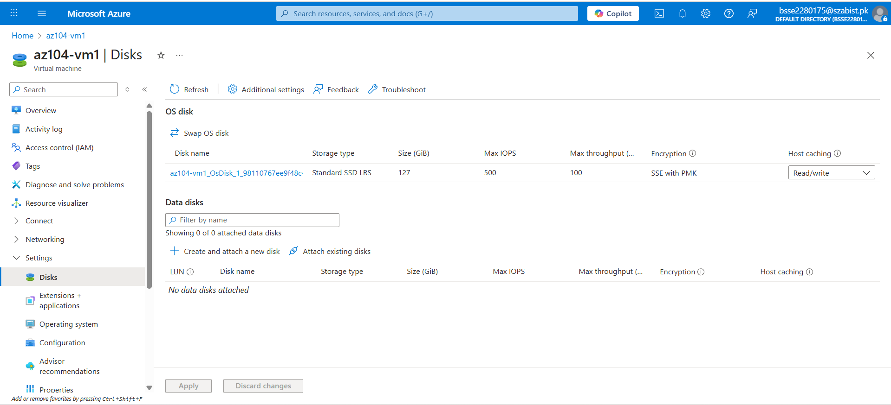

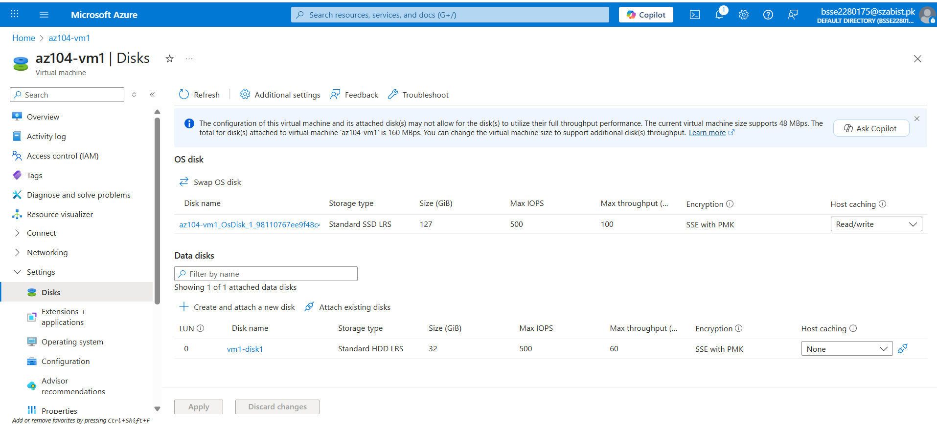

Task 3: Create and configure Azure Virtual Machine Scale Set (VMSS):

